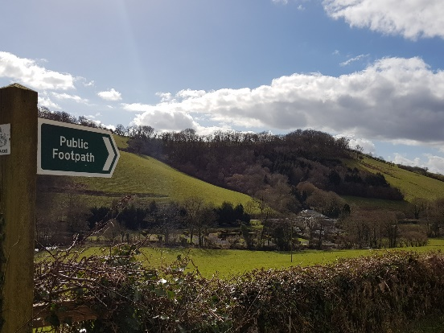
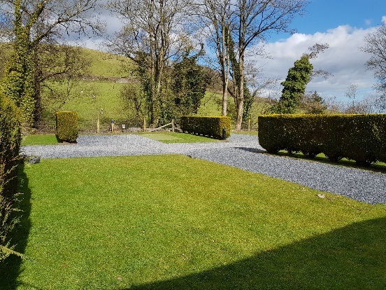
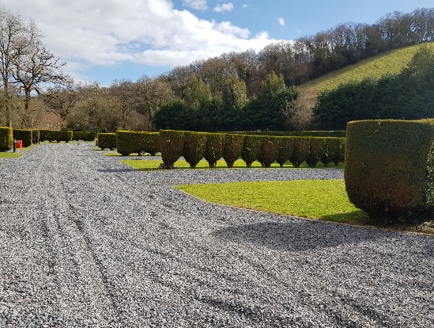
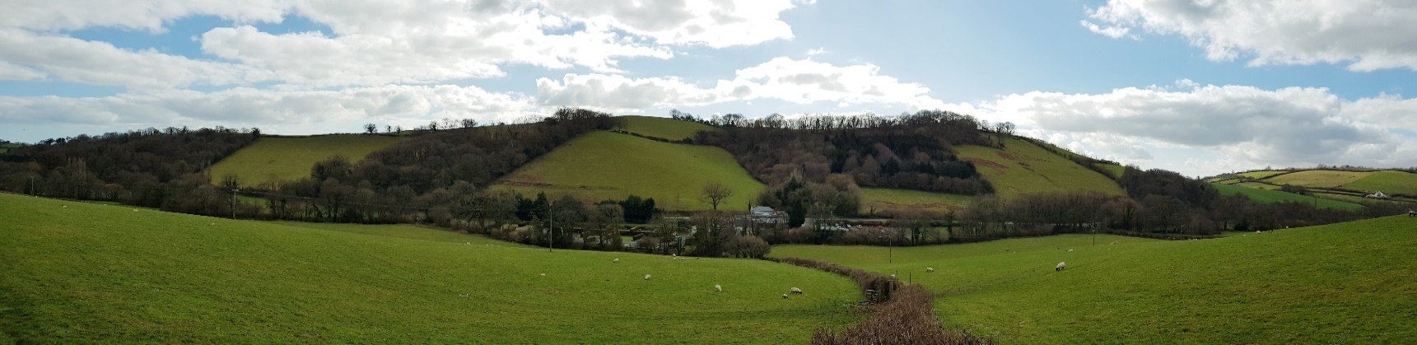
Dartmoor Halfway Campsite : 01626 824011
dhw@buccaneer.co.uk www.dartmoorhalfwayinn.co.uk
Dartmoor Halfway Inn - Campsite Rates 2023
Month | 1 | 2 | 3 | 4 | 5 | 6 | 7 | 8 | 9 | 10 | 11 | 12 | 13 | 14 | 15 | 16 | 17 | 18 | 19 | 20 | 21 | 22 | 23 | 24 | 25 | 26 | 27 | 28 | 29 | 30 | 31
Jan
Feb
March
April
May
June
July
Aug
Sept
Oct
Nov
Dec

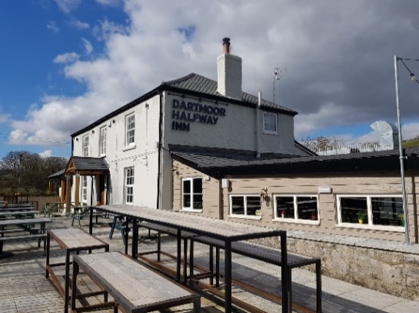
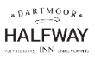 | Low season | Mid-Season | High Season
Tent pitch – open field | £20 | £26 | £28
Standard pitches – private pitch area | £24 | £28 | £30
Comfort Pitch – Electric & hardstanding | £30 | £34 | £38
Premiere Pitch – Electric, water, grey waste & Hardstanding | £34 | £38 | £40
Campsite is closed
Bell Tents | Open from April – September  please contact for details

