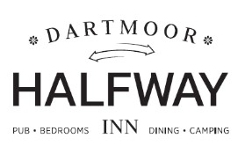

**Desserts**

**Chocolate brownie;** vanilla ice cream & chocolate sauce £8.95 (GF)

**Cheesecake of the day;** coulis & forest fruits £8.95

**Apple sponge pudding;** caramel sauce & salted caramel ice cream £8.95

**Cinnamon churros;** warm chocolate sauce & Belgium chocolate ice cream£8.95 **Dartmoor crumble;** ice cream & custard £8.95

**West Country cheeseboard;** Longman’s cheddar, Somerset brie & Stilton. Chilli jam, apple, celery & crackers £10.95

# Dartmoor sundaes £9

**Brownie;** brownie pieces, cream, chocolate & vanilla ice cream, chocolate sauce (GF)

**Eton Mess;** meringue, cream, vanilla & strawberry ice cream & forest fruits (GF)

**Caramel apple;** apple sponge pieces, cream, caramel sauce, honey combe & vanilla ice cream

# Salcombe Dairy ice creams £2.50 per scoop

Madagascan vanilla, strawberries & cream, Kenyan coffee, salted caramel, honey combe, Belgium chocolate, bubble-gum

Served with shortbread biscuits

**Salcombe Sorbets £2.50 per scoop (VE)** Alphonso Mango, lemon, raspberry, blackcurrant Served with lotus biscuits

**Salcombe Vegan ice creams £2.50 per scoop (VE)** Passionfruit, lime & mango OR rich chocolate & coconut OR coconut Served with lotus biscuits

# Milkshakes £6

Any 2 large scoops of ice cream with ice cold milk & whipped cream